Data bases Assignment 1

- . Why using a database? Advantages of databases?
Databases make retrieving and manipulating data easier because it stores them structured . Databases ensure accuracy and consistency by enforcing data integrity through constraints like primary keys and foreign keys. They can handle large volumes of data and supports access from multiple users. Through query languages it’s easier to retrieve specific information quickly. Databases also offer security features and they support regular backups as well.
2. Types of Databases?
There are Relational Databses and NoSQL Databases.
3. Characteristic of a Relational Database?
In the Relational Database data is organized in tables and there are unique identifiers such as Primary Keys and Foreign Keys. We also have relationships, links between the data . +uses sql, სქემა წინასწარაა განსაზღვრული
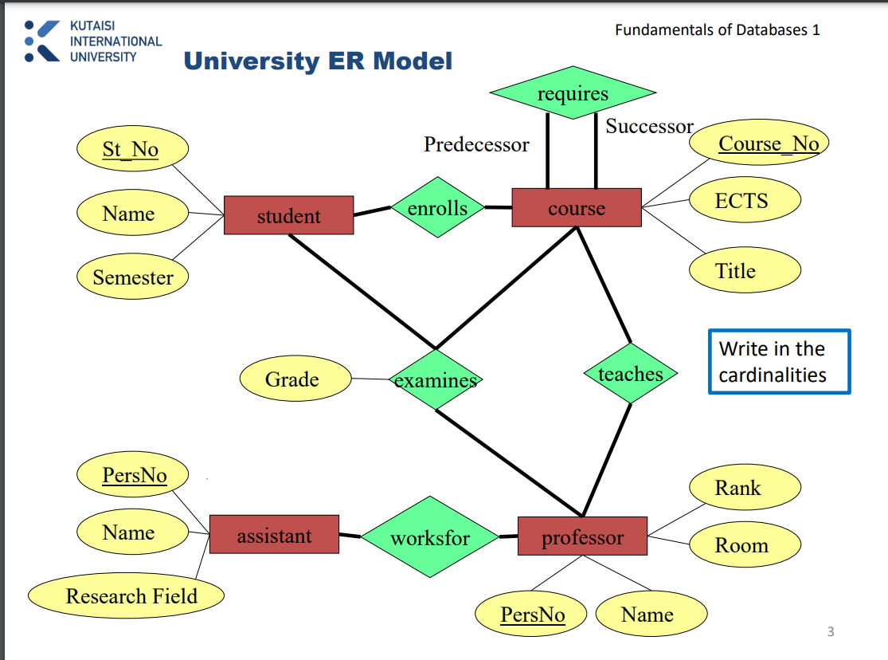
N3. A ternary relationship can be replaced by three binary relationships
correction: cannot be replaced in this situation
N4.
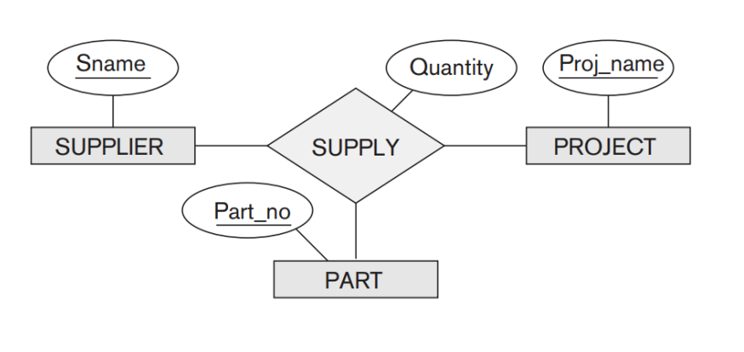
N5.

N6.
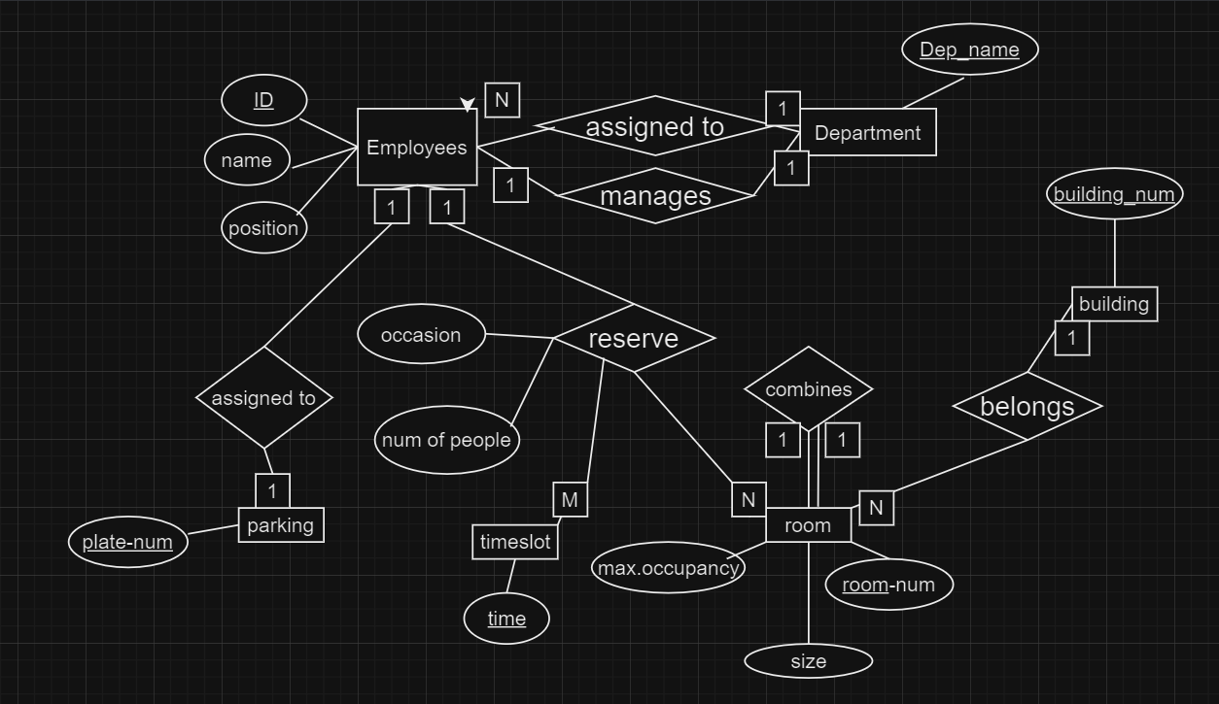

Total participation constraints:
- Every building has rooms
- Every parking lot is assigned to employee
- Every employee is a works
Partial participation constraints:
1. Employees can park their cars (if they have one) in the company parking lots.
- Some employees manage department
- Some timeslots are taken

N7.
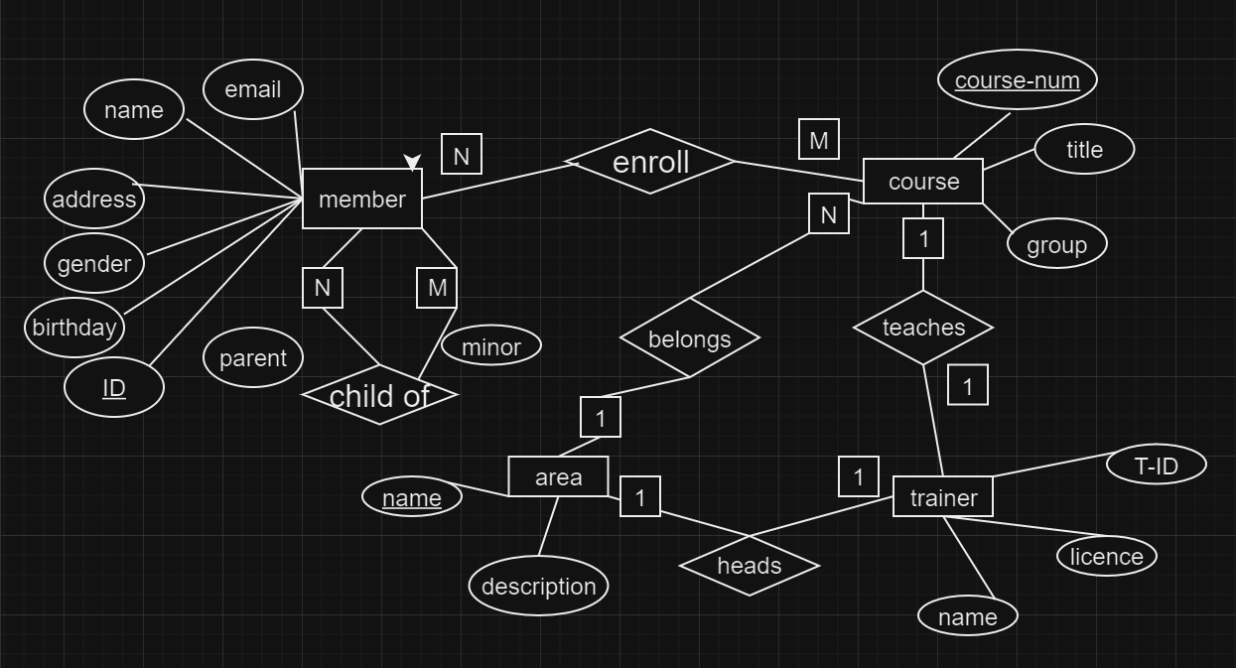
N8.
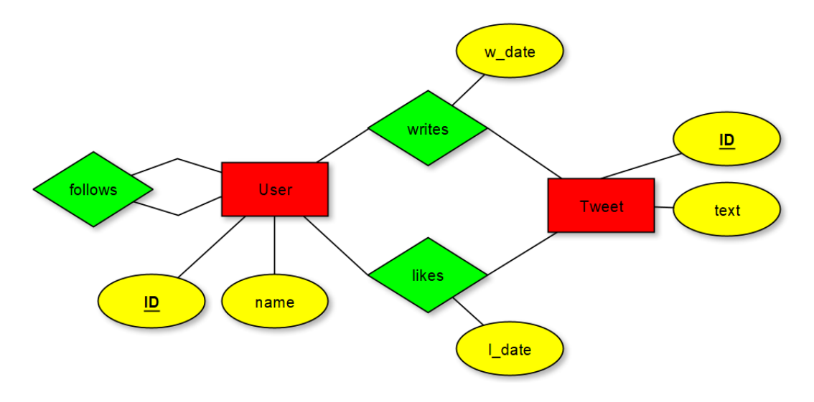
- We could assign the attribute w_date to the entity Tweet because a tweet is written by only one user so the write date is only one for particular tweet.
- We cannot assign attribute l_date to the entity tweet because a tweet is liked by many users and we cannot store this much information.

